**ZERODHA SHARE DETAILS**

**ACCOUNT ID – MWS584**

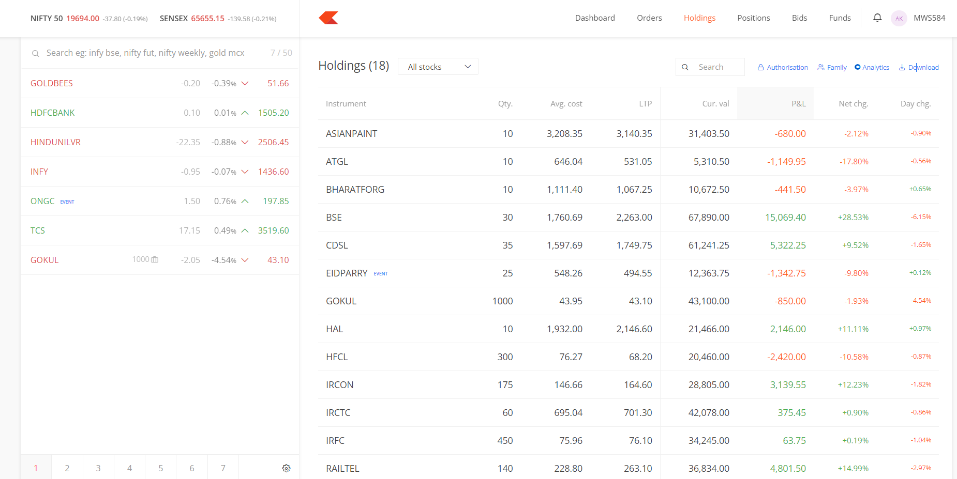

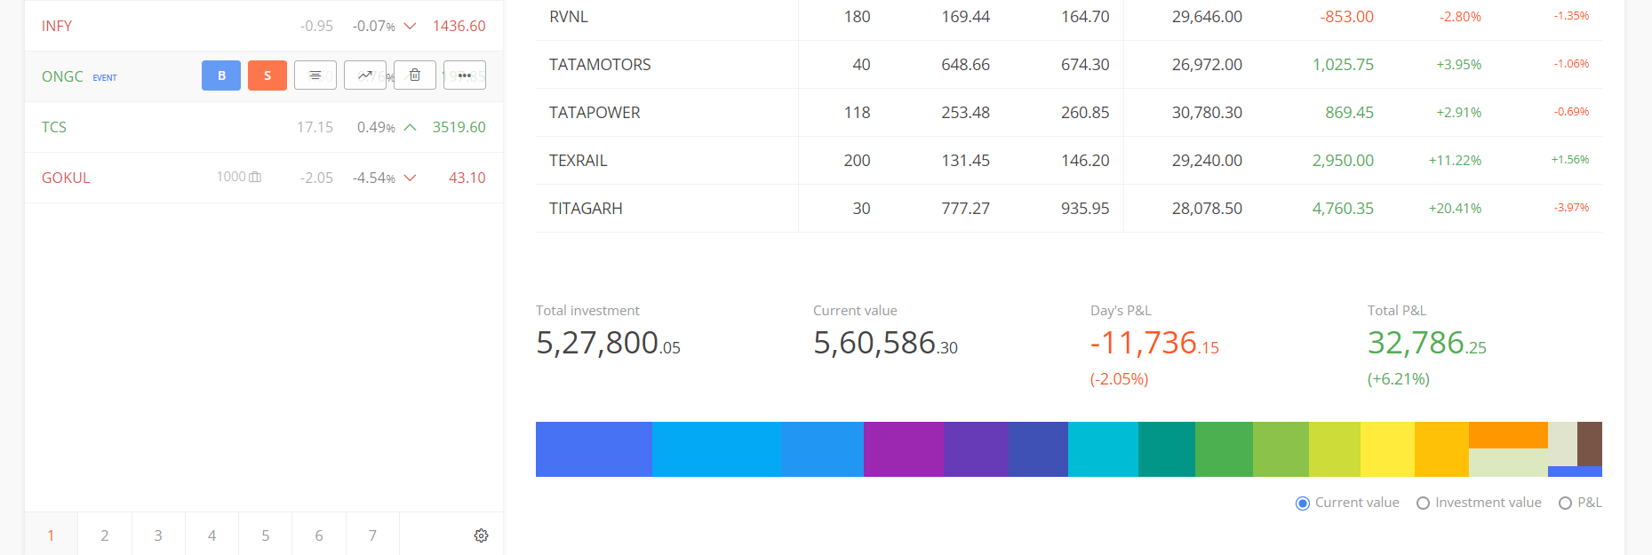

**ACCOUNT DETAILS**

